The Rich Grow Richer while the Poor Get Poorer
Name:
Professor:
Course Title:
Institution:
Date:

Introduction
The gap between the rich and the poor keeps growing in most countries. While most low-income individuals struggle to make ends meet the wealthy have continued to acquire more wealth for themselves. Anti-capitalists have raised concerns over the issues and termed it as an economic problem afflicting modern society. Around 2011, the protests against this income inequality were on the rise. At one point a great protest was held in New York near Wall Street. On matters of capitalism, this is the core of the furnace. The Occupy protestors represented a diverse set of interests and concerns, but around one slogan they could unite: "We are the 99%." The movement soon spread. According to Britain's Guardian newspaper, at least 750 similar protests followed worldwide, mostly in North America and Europe (Gibson, 2013). The protest was timely. Soon after the protest, a generational financial crisis struck which made its facets more popular as there was a sharp drop in economic growth and a sharp increase in unemployment. It promoted the public awareness that was arising on the issue of the inequality gap which has predated the economy since time immemorial. The protests complained of an unfair balance of 99% to 1% income acquisition.
The income inequality gap in the US is bigger compared to other world economies and grows annually due to various economic factors. Canada is the greatest comparator to the US as they share a lot in their economies from organization systems, international trade involvement, and labor market trends. Comparing the income inequality in the US to that in Canada, Canada is better placed. The median income in Canada is higher than that in the US despite the US having a higher income per capita. As of 2000, the Gini coefficient in Canada was 0.285 while the US had 0.376(Kwon, 2015). This work will analyze the income inequality gap between the rich and the poor in the US. Great emphasis will be on the contribution of globalization, the labor and capital tradeoff, the workplace dynamics, social factors, the role of the states and governments, and the top incomes to the income gap. Additionally, the work will analyze why this gap is an economic problem.
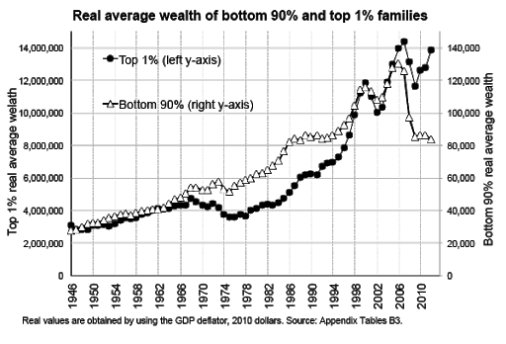
Graph 1: Income inequality in the US
Defining Income and Wealth
Income and wealth are common terms when defining economic inequality. Income is the amount of real money that flows into a household from various sources. These sources include employers, business profits, state benefits like pension, rent on real estate, prizes to mention but a few. Wealth on the other hand is people's savings and is determined by the marginal propensity to save which varies from one household to the other. Wealth is mostly determined by the shifts in the market prices of assets like bonds, property, and real estate, and stocks whose trends are fast-paced and fluctuate more rapidly. Although wealth matters, income is more important. It is the shifts in income that affect the long-term shifts in wealth (Kuhn, 2017).
Trends in income and wealth in the past decades
The gap in wealth grows wider each decade. Upper-income families are the only income tier in the US who managed to increase their wealth between 2001 and 2016. They recorded a growth median of 33%. The net-wort of the middle-income families shrunk by 20% and for the low-income, there was not only shrinking but a loss margin of 45 %( Kuhn, 2017). The upper tier wealth amounts to more than 7.4% of what the middle-income have. Compared to the upper-income families the wealth of the low-income families is 75% less. These statistics have grown adversely from 3.4 and 28 which were recorded in 1983 respectively. These trends are alarming worldwide and affecting structural and social development. Measuring income and wealth is can hardly be precise but the common measure is the Gini coefficient which only gives the income distribution details. However, it does not show the number of people succumbing to extreme poverty. Another measure of income inequality is income per household.
Causes of income inequality in the US
Globalization
Globalization has greatly contributed to the growth in wealth and income inequality in the US. Although globalization is a broad term, it can be defined as the expansion of the global and individual country economies and the integration of complex ideas like internationalization and multinationalism in trade, culture, communication, and lifestyle all supported by technology (Bergh, 2010). Technology is the new norm in the US and the world at large. In this work, the main focus is on economic globalization which is has been changed in terms of technology and information sharing, internal migration, production business operations, trade and investment, and finance. Globalization has multiple benefits. Nonetheless, the benefits of globalization are not uniform across different economic tiers. Although all the aspects of globalization affect the economic inequality gap, technology and communication have more impact.
Technology and Communication Although the Luddites in the 19th Century have been branded technophobic, they raised very relevant concerns impact of technology on the income gap. They were textile workers who smashed a newly introduced machinery that was meant to mechanize their work. Their concerns were the threat that this posed in their jobs. The productive output in the US has risen in the past three decades but the number of labor hours has remained the same. The impact on income has been doubled income for the 1% top income individuals, a 10% decline for the 90% low-income individuals (Jaumotte, 2013). The top income individuals are mostly the winners, the inventors, and those whose work is made easier by technology while the losers are the low-income individuals whose labor and importance in the labor market are substituted by technology.
Specifically, technology has led to skill devaluation for the low-income individual and revaluation of skills for the top position individuals. It has changed the labor, creating new different roles. Whilst it's important to integrate it everywhere, technology is a major driving factor for the current economic inequality. Technology is winning in all aspects, with its vaults giving margins to education and forcing an unprecedented change in education which drives income inequality (Manyika, 2017). Technology is currently a threat to the jobs of low-education individuals who belong to the low-income class. On the other end, the upper income can leverage technology to better their operations and add on to their returns on education.
Trade The other four factors under globalization affect the income gap based on the income distribution from the country to the families. Since globalization has increased trade, the labor market has become volatile, hiring and firing of workers have become easier since trade unions are also gradually losing their power, the increase of cheap imports has widened the income gap. Mostly, the upper-income families have the capabilities to import, while the lower-income are small scale producers, cheap imports alter the market prices in favor of the upper-income at the expense of the poor and middle class.
Investment In terms of investment, globalization has steered, foreign direct investment. Only moguls can purchase and operate businesses abroad. Mostly the operation cost is lower compared to the one in the US which increases the returns on investment. Additionally, globalization has promoted offshoring jobs in the US and low-income individuals suffer the most. In such arrangements, the income of the low-income individuals keeps shrinking with the available jobs getting more competitive at wage amounts where the employers have greater bargaining power. The employee monopsony has been greatly suppressed.
Government capital expenditure Globalization has resulted in the shift of income from capital to labor increasing the income gap. Today, a greater percentage of the US national income is directed to corporations and business owners while the workers receive a small percentage. This is because more funds are directed on technology such as AI, robots, and automation processes which are gradually substituting jobs. This shift in income has its effects leaning more on low-income individuals.
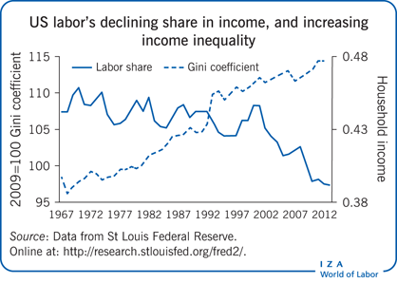
Graph 2: Labor and the income inequality gap
Changes in the traditional workplace
The current change in workplace trends, with the adoption of flexy, remote working, and reduction of traditional jobs is shaping the income trends. Short-term and part-time jobs are increasing in popularity. Over 50% of American jobs are of this nature. While some of the netizens welcome the idea, for others it is an imposed idea. Nonetheless, this plays an integral role in the income inequality gap. The shift has hollowed out the workforce, with traditional workforces like accountants and clerical workers with middle-level skills declining. This is shrinking the income and consequently, the wealth of individuals is declining. The middle-level workforce share decreased from 53% by 8% between 1995 and 2010(Jacobs, 2016). Economically the workforce graph is U-shaped and this implies a negative change in income inequality steered by an increased proportion of workforce for the low and highly skilled laborers. On this same grounds, the wages and work conditions contribute to work together to increase the gap between the poor and the rich. The low-income laborers receive lower wages since they work for fewer hours, spent more time unemployed transitioning from contract to the other, and low per hour income compared to the permanently employed laborers. The employee monopsony is suppressed with minimal chance to complain for these precariat workers. Technology is a major steering factor for this current job system. Besides technology, the demographic mix in the workforce is changing with more women joining the working population and a majority joining the part-time jobs to suit their role as corporate personalities and homemakers (Kollmeyer, 2013). Also, temporary workers have less protection compared to permanent workers. Employers prefer the former since they can easily be fired and hired and provide the same labor at cheaper costs now and in the future. Further union membership is declining due to the increased privatization which means less representation of employees.
Societal changes
The disparity in income between the rich and the poor is increasing due to societal changes. Assortative mating accounts for over 40% of the working couples with almost the same amount of earnings. Compared to three decades ago, this is an increase of 7%. This has resulted from women joining the workforce and having skills that match those of men. In those past decades a doctor would marry a nurse but today there are higher chances of marrying another doctor. These trends concentrate income only in a few households. The poor remain poor and the rich get richer. Additionally, the family structure has changed in the US with over 25% being led by single parents. This means one pay-cheque lowering income in the family (Huber, 2014).
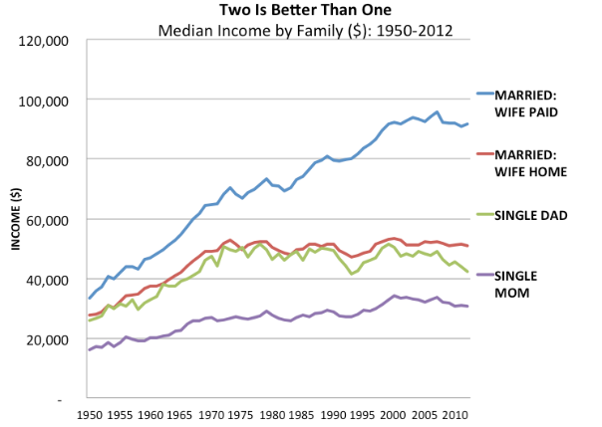
Graph 3: Effect of marriage on the income gap
Governmental policies
Additionally, the government plays a major role in the income trends within a country. Policies determine the spending power and this affects the disposable income from taxes and duties. Regulations on markets increase competition and reduce job security and employee monopsony. This affects the wages earned which determine the propensity to either save or spend depending on the disposable income after taxes. In the past century, taxes minimized the gap as the high income paid more compared to the low-income individuals and the taxes were used to support the low-income individual by the state. However, in the current era, the US government has cut its expenditure on unemployment benefits, income taxes keep getting aggressive and the high-income individuals are enjoying fewer taxes (Auten, 2017). Today, governments have fallen back in regulating the labor market too.
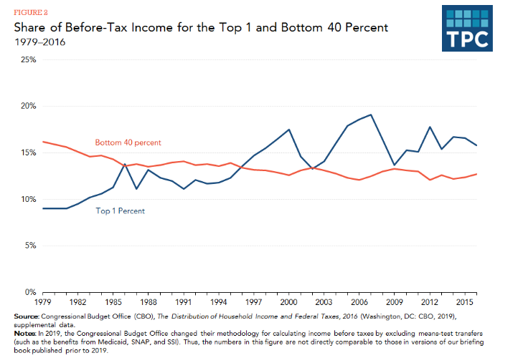
Graph 4: Impact of Taxes on the Upper and Lower-income classes.
Effects of income inequality gap in the US
This income inequality gap has detrimental effects not only on the economy but also to the people of the US. Part of the community feels that the gap is economically good as it increases opportunities for entrepreneurs and is a good venture for investment. Some economists support the idea of the inequality of income but are keen to specify that this complex relationship is only good up to some point past which leads to a decline in the growth rate of the economy. Other economists state that disparity in the economy affects the behavior patterns of the various income classes and subsequently the nation. In the US where the lower-income individuals are more, the ability to invest in education, better medical care for all becomes curtailed. The quantity demanded and demand for goods goes down since the income amongst the middle-class individuals is contracted. While it is expected that the rich have their money in banks increasing lending investment capital, the rich in the US have in the current decade used their economic power to lobby for their interests and invested heavily overseas thanks to globalization. Besides these aspects, the community has grown into a state of distrust, with a lot of social unrest and volatility of policies.
Recommendations to reduce the gap between the rich and the poor
There are several ways to reduce the income inequality gap. The American government should rethink some of its policies. While it is clear that economic decisions have a role in the inequality gap, some inequalities go beyond income. The US government should face the fact that globalization has become part of the world today. Also, it should appreciate the emerging market trends and prepare the middle and low-class population by encouraging skill advancement through companies. The leaders should be at the forefront in the management of the globalized economies in various states and encouraging more local investment and discouraging importation of cheap goods at the expense of local producers.
The rich and poor gap is an economic problem that cannot be resolved directly by economic decisions. A better and viable solution is inclined more on how power is exercised by both the rich, the politicians, and corporations (Kelly, 2009). A better policy may need to focus more on supporting young people from poorer families in education and on creating health and lifestyle programs specifically targeted at low-income groups. This way the gap between educations will soon keep up with the pace that technology is setting. Additionally, improving education amongst the middle and low-income classes will also solve the issue of assortative marriages and improve the income distributions in households.
Government policies like taxation can be a good way to reduce the gap. Congress should increase taxes on the top income individuals and use the extra funds to improve education and unemployment benefits. However, taxation reform is not a new idea since the U.S. has a progressive tax system in name, but in practice, there are gaping loopholes. Closing up the loopholes, and taxing capital gains and dividend income as regular income is one of the more powerful tools society can use to fight income inequality. Another tax-based solution would be the imposition of a hefty estate tax which will narrow the wealth gap in the sense that there will be less generational moguls. The estate tax will ensure that the riches inherited across generations is less. However, with the economic power that the wealthy families have, it will require persuasion and a more humanitarian approach for this policy to succeed. 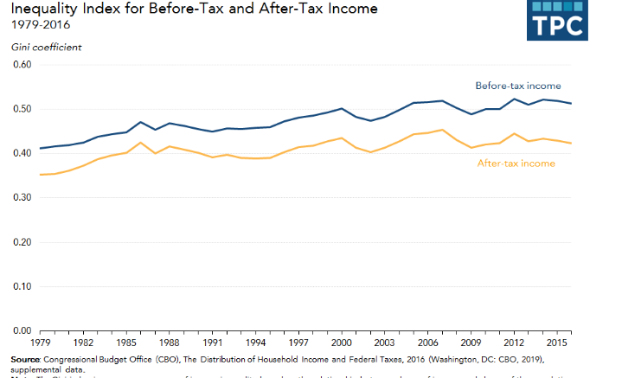
Graph 5: Taxation and income inequality
There is also a need for enhancement of the societal value of the family institution. Currently, individuals have decreased the weight and respect that they had accorded to the institution compared to decades ago. With more value for family, the issue of single parenting will be resolved and more the income inequality in single-parent families will be resolved. There will be some level of equality in expertise between individuals in all the classes of the economy.

References
Kelly, N. J. (2009). The politics of income inequality in the United States. Cambridge University Press.
Auten, G., & Splinter, D. (2017). Income inequality in the United States: Using tax data to measure long-term trends. Draft subject to change. http://davidsplinter. com/AutenSplinter-Tax_Data_and_Inequality. pdf.
Huber, E., & Stephens, J. D. (2014). Income inequality and redistribution in post-industrial democracies: demographic, economic and political determinants. Socio-Economic Review, 12(2), 245-267.
Kollmeyer, C. (2013). Family structure, female employment, and national income inequality: A cross-national study of 16 Western countries. European sociological review, 29(4), 816-827.
Bergh, A., & Nilsson, T. (2010). Do liberalization and globalization increase income inequality?. European Journal of political economy, 26(4), 488-505.
Jacobs, D., & Dirlam, J. C. (2016). Politics and economic stratification: Power resources and income inequality in the United States. American Journal of Sociology, 122(2), 469-500.
Kwon, R., & Roberts, A. (2015). Financialization and Income Inequality in the New Economy: An Exploration of Finance's Conditional Effects. Sociology of Development, 1(4), 442-462.
Manyika, J. (2017). Technology, jobs and the future of work.
Jaumotte, F., Lall, S., & Papageorgiou, C. (2013). Rising income inequality: technology, or trade and financial globalization?. IMF Economic Review, 61(2), 271-309.
Kuhn, M., Schularick, M., & Steins, U. I. (2017). Income and wealth inequality in America. Journal of Political Economy.

